Py Peripheral Functional Test User Guide

|  |  |
| --- | --- |
| Document ID |  |
| Date |  |
| Distribution |  |
| Version |  |

Revision History

|  |  |  |
| --- | --- | --- |
| **Revision** | **Date** | **Change Description** |
|  |  |  |
|  |  |  |
|  |  |  |
|  |  |  |

**Table of Contents**

Contents

1 ABBREVIATIONS 3

2 INTRODUCTION 3

2.1 Purpose 3

2.2 Audience and prerequisites 3

3 PY Peripheral Function Test 4

3.1 Installing 4

3.1.1 Windows 4

3.1.2 Linux 4

3.2 Running 4

3.3 Using 5

3.3.1 Connecting UART 6

3.3.2 Select Items Test and send 7

# ABBREVIATIONS

|  |  |
| --- | --- |
| **Abbreviation** | **Explanation** |
|  |  |

# INTRODUCTION

## Purpose

This guide will give an overview on how to use the Py Peripheral Functional Test, to control connect UART and test board.

## Audience and prerequisites

This document is intended for verifying board and factory testing.

It is a prerequisite …

# PY Peripheral Function Test

## Installing

The Py Peripheral Function Test provides a GUI application written in python. You may use this application to manage and test your TAG Board. In order to run the GUI application you must have python installed together with the wxPython package. The GUI has been tested with python 2.7.

### Windows

Get and install python 2.7 : <http://python.org/download/>

<http://python.org/ftp/python/2.7.3/python-2.7.3.amd64.msi>

For wxPython: <http://wxpython.org/download.php#stable>

Remember to choose a version of wxPython which matches your python version.

### Linux

sudo apt-get install python2.7 python-wxgtk2.8 python-tk

## Running

Once python and wxPython has been installed, the Py Peripheral Functional Test application may be started by running the file gui.py from the pyFunctionalTest folder.

## Using

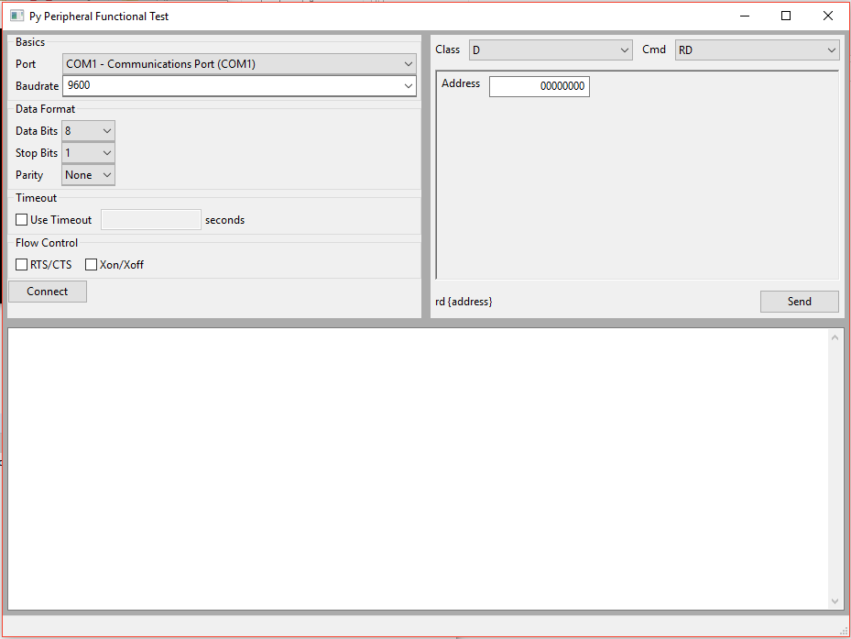

**Figure 1: Py Peripheral Functional Test main window**

### Connecting UART

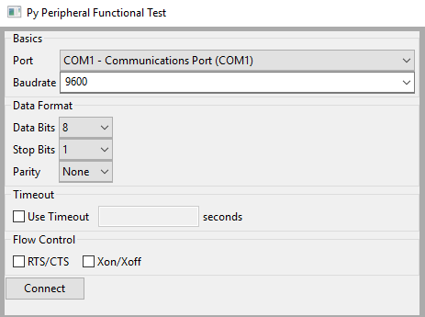

* **Port**: Select Port
* **Baudrate**: 115200
* **Data Bits**: 8
* **Stop Bits**: 1
* **Parity**: None

Press “Connect” button when finishing setup.

### Select Items Test and send

